**BOOK DOCTOR ONLINE**

**Contents**

|  |
| --- |
| 1. ABSTRACT |
| 1. Functionality behind the project |
| 1. Difficulties faced during implementation |
| 1. Patterns used in the project 2. Observer design pattern 3. iterator design pattern 4. factory design pattern 5. command design pattern |
| 1. unit testing |
| 1. project explanation |
| 1. conclusion |

**ABSTRACT :**

The project which we established is using for patients to book their doctor online which I preferred by them at a preferable time by booking the slots which are provided by the doctors. Here with the help of this project there is no need for waiting in a long queue to make an appointment of a doctor at the hospital. From this project we can easily book the doctors appointment and we can see whether the doctor is available at the hospital or not. Nowadays we are struggling with the pandemic due to covid and we are not willing to go the cluster of people. So, we can easily access the appointments with this project without any fear of pandemic. From this project we can login and see the doctor is available or not on a particular date and for a particular slot, so that we will book an appointment by checking his availability with ease by not going to the hospital or a clinic with the help of this project.

**Functionality Behind the Project:**

There is One hospital which has so many Doctors and So Many Patients here we can find the One To Many Relation Ship so i implemented Observer Design Pattern on behalf of this logic and we can notify any notification to all doctors and patients as a representative of Hospital.

As there will be Doctors and Patients, I planned to have a factorial design pattern to make use of Object Creation of respective Class.

Iterator Design pattern is used for iterating any list of records, I planned to have it to get all doctors and patients

Command design pattern is used to execute commands binded in the functionality.

**Difficulties Faced During Implementation:**

* Combining multiple design patterns is critical task which holds me some time so I over come this by revising previous lectures.
* Wasted so much time while booking the slots
* The thinking of placing the doctor for patient’s idea
* The timetable scheduling.
* Notify patients.

**Patterns used in the project:**

**Observer Design Pattern:**

Observer pattern is used when there is one-to-many relationship between objects such as if one object is modified, its dependent objects are to be notified automatically. Observer pattern falls under behavioural pattern category.

**Iterator Design Pattern:**

Iterator pattern is very commonly used design pattern in Java and .Net programming environment. This pattern is used to get a way to access the elements of a collection object in sequential manner without any need to know its underlying representation.

Iterator pattern falls under behavioural pattern category.

**Factory Design pattern:**

Factory pattern is one of the most used design patterns in Java. This type of design pattern comes under creational pattern as this pattern provides one of the best ways to create an object.

In Factory pattern, we create object without exposing the creation logic to the client and refer to newly created object using a common interface.

**Command Design Pattern:**

Command pattern is a data driven design pattern and falls under behavioural pattern category. A request is wrapped under an object as command and passed to invoker object. Invoker object looks for the appropriate object which can handle this command and passes the command to the corresponding object which executes the command.

**Unit Testing:**

# What is Unit Testing?

Unit testing is one of the software testing types which includes the initial testing phase where the smallest components or the modules of a software are tested individually. With this method of testing, both testers and developers can isolate each module, identify and fix the system defects at a very early stage of the software development lifecycle (SDLC). Primarily, a unit test verifies different behavioural aspects of the system under test and can be broadly classified into state-based and interaction-based unit testing.

A typical unit test consists of three phases which include the first initialization phase where it initializes a small piece of an application it wants to test. The second phase is the addition phase where it adds a stimulus to the system under test and finally, the third phase is the result phase where it observes the resulting application behaviour. Evidently, if the observed behaviour is consistent with expectations, then the unit test passes else it fails. This indicates there is a problem somewhere in the system under test. These three test phases are named as Arrange, Act and Assert or commonly known as AAA.

## Why Unit Testing is important to perform?

Unit Testing is the software testing technique where a group of software program components or modules are tested individually. This technique effectively helps in validating the accuracy of a section of code by considering stubs, mock objects, drivers, and unit testing frameworks. Since it is practiced at the initial testing phase, this testing technique assures to identify and fix the bugs at the early stage of SDLC even before they become expensive for the enterprises to fix when identified at a later stage.

Some developers may attempt to save time by performing minimal unit testing, or when unit testing is skipped, it obviously leads to higher defect fixing costs during system testing, integration testing, and even beta testing when the application is completed.

Moreover, in addition to these, unit testing helps the development teams to understand the code base, validate the correctness of the developed code, reuse the code, and to make the changes faster in the code.

With a proper unit testing practice in place, the developers and testers can help to save time as bugs can be identified early in the process as it is the initial phase of testing. And, skipping or limiting the practice of unit testing can adversely increase the defects and it becomes complex to fix them at a later stage. Hence, it is essential to practice unit testing at the initial stage of the software testing process before planning for the integration testing.

## 

## What are the benefits of Unit Testing?

– Isolates a section of code and validates its correctness

– Helps in identifying and fixing the bugs at the early stage of the SDLC process

– Assures to reduce the cost as bugs are resolved at the earliest

– Helps the developers to improve the design by allowing refactoring of the code

– Assures in simplifying the debugging process

– With the proper unit testing practice, components that are integrated after the build can assure in achieving a quality product.

**Project Explanation:**

Here this is the welcoming page for booking the appointment by the help of this project.

As we seen in the above screenshot, we have to choose one choice from the above two choices. Like, 1 for doctor and 2 for patient and we need to press enter button to go to the next part.

As Doctors had selected one from the above choices then doctors must select the above options as registration and login. If doctors are new to this project, doctors must register themselves by selecting the option 1 and then enter. If doctors are already registered in this project doctors must go to sign in option by clicking 2 and then enter.

Here doctor had selected the registration part so they have to give the details as per the requirements. They have to give their id and name and the username and the password for the login purpose for the further use. As we can see the doctor registration success message will be shown then it was the exact one which will shows us the registration has been completed.

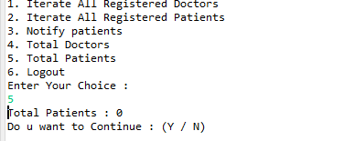

If doctors who had logged in to the project can see the total head count of the total patients by pressing the option 5. As we seen in the above screenshot it was letting know us the count of the patients. As we see we are getting the question to continue to further or not. If we press y and enter then doctors will be continue with the process and if they press the n and enter then the compilation will be stop and respectively, they will be logout from the project.

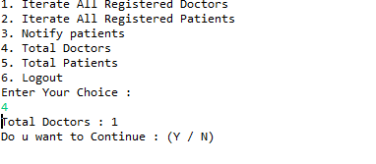

As we seen in the above screenshot that that doctors whom they are logged in within the project. As per the screenshot the doctors can know the head count of the other doctors by pressing the 4 key and then enter. We will be left by a question to continue further or not.

After selecting the doctor login by the doctors, it will give them the access to the give the username and password. So, after they enter the details they will see the message as doctor login success as name (name of the doctor). They are having a lot of options to choose as above screenshot.

As we seen in the above screenshot doctors has selected the 1 and that is iterate all registered doctors. It will show that how many doctors are they’re with in this project whom they are registered. As we see we are getting the question to continue to further or not. If we press y and enter then doctors will be continue with the process and if they press the n and enter then the compilation will be stop and respectively, they will be logout from the project.

If we want to select the choice as patient, we have to select the 2 and then enter. It will give us the respected options to choose like we have to register or to login as a patient.

The patient who had selected the choice as patient. If they are first to come to this project they has to register as new and if they are already within the project just they have to select login. Here we are selected as patient registration by entering 1 and pressing enter and we have to give the patient id, name, username and the password for the purpose of the registration. As we were to see the message as patient registration success it will be succeeded.

The patient has to login after the registration process and then we must give the essential credentials. Then they will be log in as the patient and they can get the options to choose as the above screenshot as iterate all registered patients, book a doctor and logout as well.

By selecting the option as 1 in the patient choice section after logging in to the project as patient if we select the option1 as the above picture we can get the details of patients who are registered with in this project. We will be asked a question as to continue to further process or not if we want to continue, we have press y and then enter. If we don’t want to continue to the project further, then we have press n and then enter then we will be thrown out of the project by stopping the compilation and respectively logged out from the project as well.

As we are selected the option as book a doctor for the appointment of doctor to get treatment we have to select 2 and then enter we can see the timings of the doctors which are available and we have to the slot one of those slots by helping with the numbers we can see in the above screenshot as 1,2,3 and 4. If we want to get the slot between 8 am to 10 am we have select the slot1 by 1 and then enter then the slot will be booked. If we want to get the slot between 11 am to 1 pm we have select the slot1 by 1 and then enter and then enter then the slot will be booked. If we want to get the slot between 2 pm to 4 pm we have select the slot1 by 1 and then enter and then enter then the slot will be booked. If we want to get the slot between 5 pm to 8 pm we have select the slot1 by 1 and then enter and then enter then the slot will be booked.

As we seen above screenshot the slot 1 has been selected by the patient the booked message will be appeared and then also how many slots were remaining in that time also will be shown by the number of slots for that timing.

By selecting the option 3 to logout of the project. This logout option will be same for the doctor and the patient as well. There will same process we have to select the option which we have to given to logout that has to be entered and then press enter. You will be successfully logout from the project and the message will be shown.

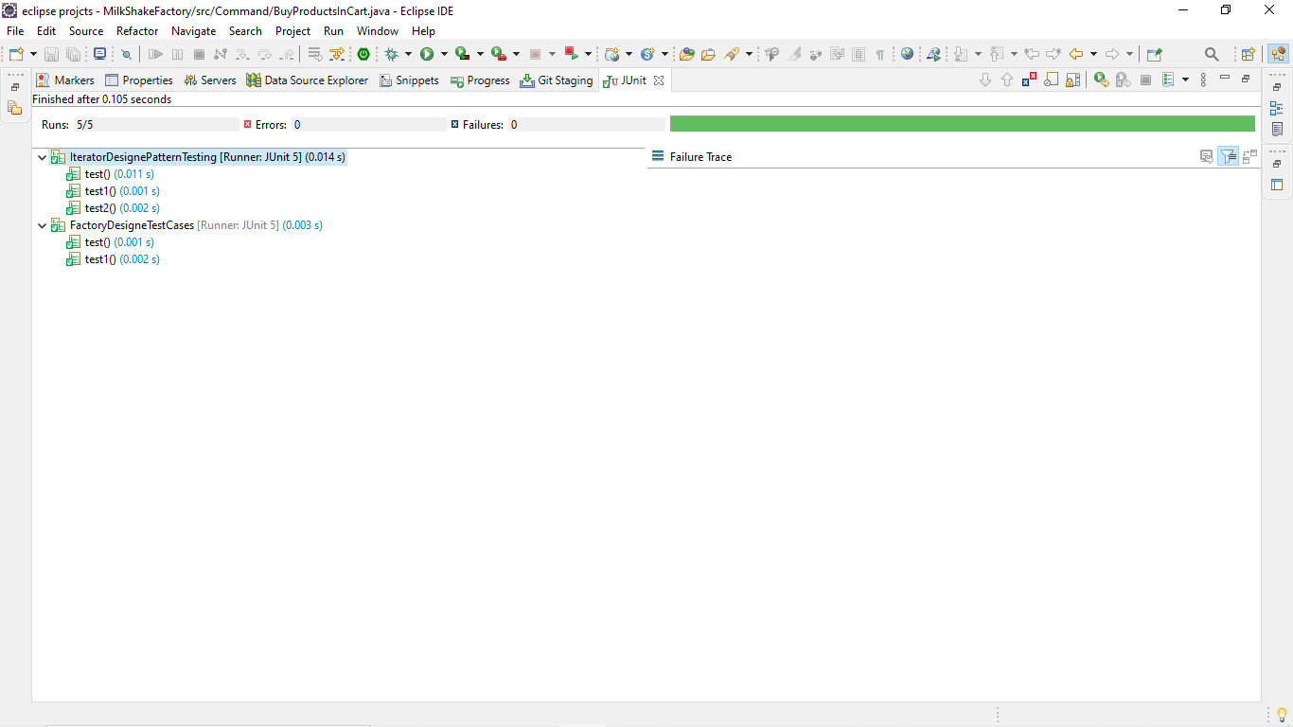

Here we have tested two patterns regarding this project, and they were iterator design pattern and the factory design pattern.

**Conclusion:**

Hence, it is concluded that the project which is used to place the booking for patients regarding the particular slot of the doctor. This planning method aids in the selection of the functional qualities. This project was created with the help of java design patterns.